CREATION OF DOCTORS TABLE

create table doctors

(

name varchar(20),

specialization varchar(30),

gender varchar(10),

Available_Day varchar(10),

date_of_birth date,

work_exp_in_years int not null

);

INSERT INTO doctors(name,specialization,gender,Available_Day,date_of_birth,work_exp_in_years)

VALUES('Binoy Shah','Dermatologist','Male','Tuesday','12 January 1978','16');

INSERT INTO doctors(name,specialization,gender,Available_Day,date_of_birth,work_exp_in_years)

VALUES('Kalpana Sanghvi','Urologist','Female','Monday','18 July 1991','3');

INSERT INTO doctors(name,specialization,gender,Available_Day,date_of_birth,work_exp_in_years)

VALUES('Siya Sharma','Dentist','Female','Thursday','24 September 1983','10');

INSERT INTO doctors(name,specialization,gender,Available_Day,date_of_birth,work_exp_in_years)

VALUES('Rohit Patel','Heart Surgeon','Male','Wednesday','10 April 1975','17');

INSERT INTO doctors(name,specialization,gender,Available_Day,date_of_birth,work_exp_in_years)

VALUES('Aakash Shah','Pediatrician','Male','Saturday','26 January 1986','6');

INSERT INTO doctors(name,specialization,gender,Available_Day,date_of_birth,work_exp_in_years)

VALUES('Krisha Jain','Psychiatrist','Female','Friday','11 December 1981','11');

INSERT INTO doctors(name,specialization,gender,Available_Day,date_of_birth,work_exp_in_years)

VALUES('Rishabh Sheth','Heart Surgeon','Male','Monday',' 15 November 1985','8');

INSERT INTO doctors(name,specialization,gender,Available_Day,date_of_birth,work_exp_in_years)

VALUES('Bhavya Trivedi','Anesthesiologist','Male','Sunday','23 March 1971','20');

INSERT INTO doctors(name,specialization,gender,Available_Day,date_of_birth,work_exp_in_years)

VALUES('Ketan Parekh','Dermatologist','Male','Tuesday','19 December 1982','12');

INSERT INTO doctors(name,specialization,gender,Available_Day,date_of_birth,work_exp_in_years)

VALUES('Isha Panchal','Gynecologist','Female','Friday','26 May 1983','10');

Select * from DOCTORS;

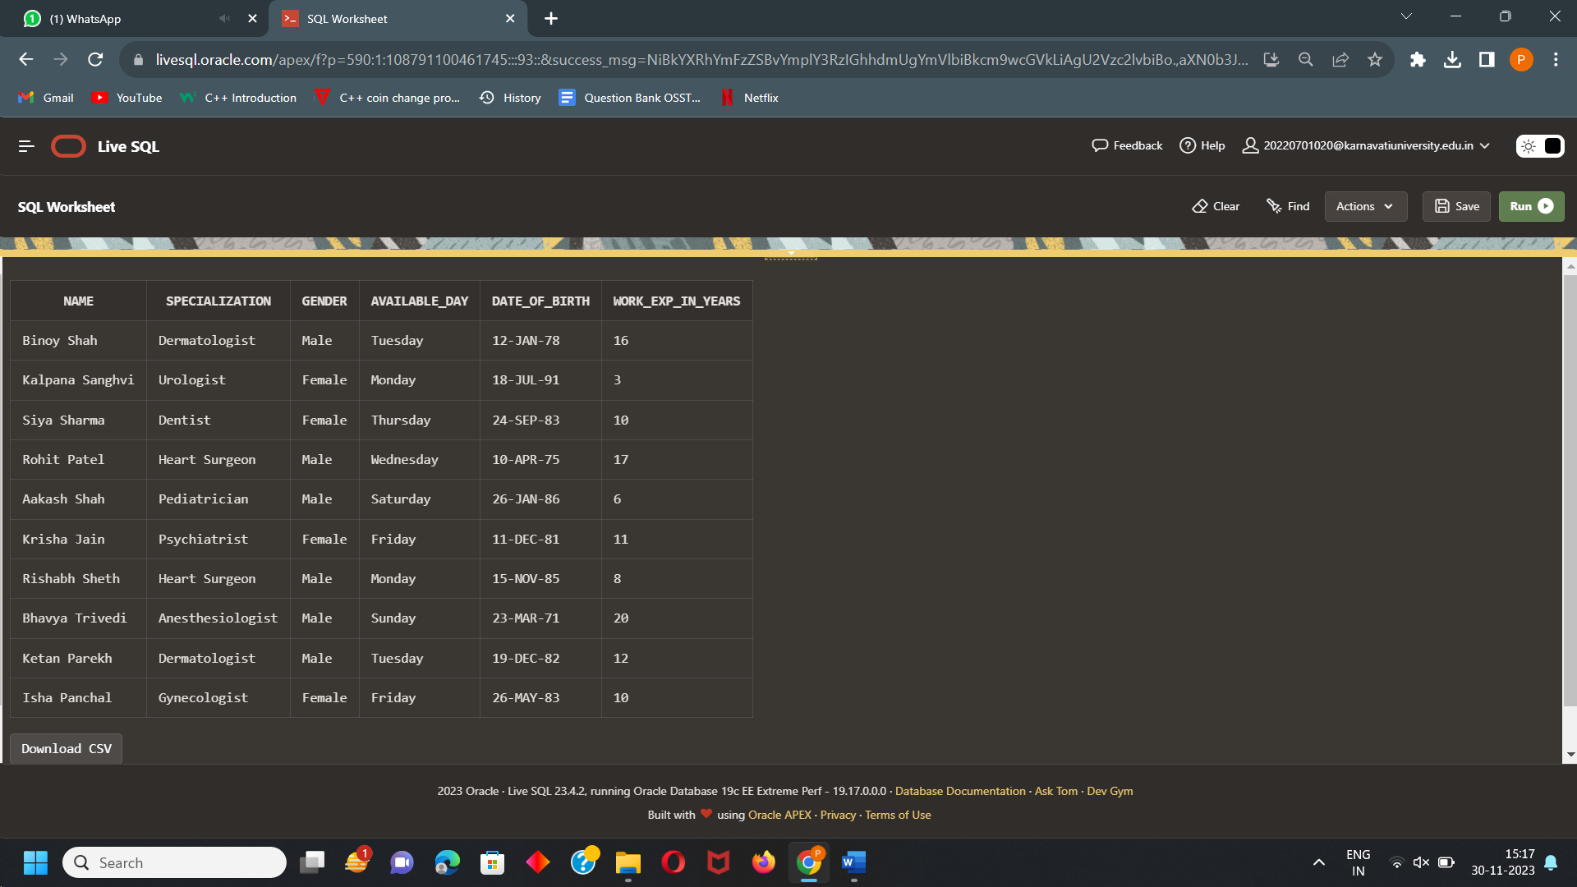

CREATION OF MEDICINE TABLE

CREATE TABLE MEDICINE

(

MED_NAME VARCHAR2(20),

PRICE integer not null,

USED_FOR varchar(70),

MFG_DATE DATE,

EXP_DATE DATE

);

INSERT INTO MEDICINE (MED_NAME, PRICE, USED_FOR, MFG_DATE , EXP_DATE)

VALUES('Nivolumab','3000','Cancer','20-December-2023','24-May-2024');

INSERT INTO MEDICINE (MED_NAME, PRICE, USED_FOR, MFG_DATE , EXP_DATE)

VALUES('Bisoprolol','5000','blockage in heart','20-December-2023','24-March-2024');

INSERT INTO MEDICINE (MED_NAME, PRICE, USED_FOR, MFG_DATE , EXP_DATE)

VALUES('Glucosamine Sulphate','1000','Damaged Ligaments','20-December-2023','15-June-24');

INSERT INTO MEDICINE (MED_NAME, PRICE, USED_FOR, MFG_DATE , EXP_DATE)

VALUES('Theophylline','2000','Damages lungs','20-December-2023','12-August-24');

INSERT INTO MEDICINE (MED_NAME, PRICE, USED_FOR, MFG_DATE , EXP_DATE)

VALUES('topiramate','800','Brain Disorder','20-December-2023','12-April-24');

INSERT INTO MEDICINE (MED_NAME, PRICE, USED_FOR, MFG_DATE , EXP_DATE)

VALUES('Ferrous sulfate','200','Mineral Deficencies','20-December-2023','12-February-24');

INSERT INTO MEDICINE (MED_NAME, PRICE, USED_FOR, MFG_DATE , EXP_DATE)

VALUES('Aspirin','1500','pain killer','20-December-2023','12-July-24');

INSERT INTO MEDICINE (MED_NAME, PRICE, USED_FOR, MFG_DATE , EXP_DATE)

VALUES('Gas-X,','500','Gas','20-December-2023','12-January-24');

INSERT INTO MEDICINE (MED_NAME, PRICE, USED_FOR, MFG_DATE , EXP_DATE)

VALUES('pantoprazole,','400','Acidity','20-December-2023','12-March-24');

Select * from MEDICINE;

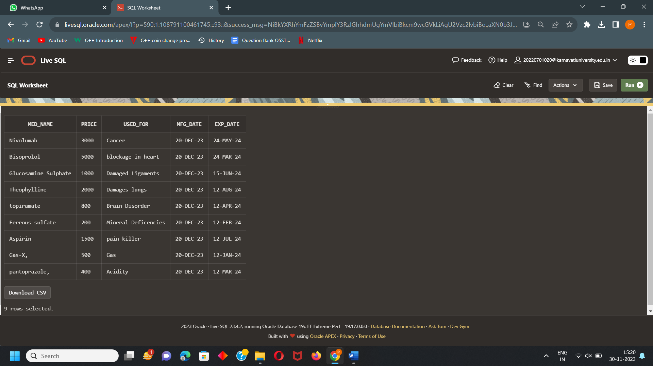

CREATION OF PACKAGES TABLE

create table PACKAGES (

Package_ID number,

Package_Name varchar(30),

Specification varchar(40),

Used_for varchar(30),

Cost int not null,

Report varchar2(20),

Patient_ward varchar2(20),

Type varchar(20)

);

INSERT INTO PACKAGES(Package_ID,Package_Name,Specification,Used_for,Cost,Type,Report,Patient_ward)

VALUES('4','Deluxe Heart Screening Package','Detailed heart assessment','heart','5000','Deluxe','not included','included');

INSERT INTO PACKAGES(Package_ID,Package_Name,Specification,Used_for,Cost,Type,Report,Patient_ward)

VALUES('1',' Basic Checkup','Body General Checkup','Overall body','1000','Normal','not included','not included');

INSERT INTO PACKAGES(Package_ID,Package_Name,Specification,Used_for,Cost,Type,Report,Patient_ward)

VALUES('11','Premium Heart Package','Diagnostics using angiograms','heart','4000','Golden','included','not included');

INSERT INTO PACKAGES(Package_ID,Package_Name,Specification,Used_for,Cost,Type,Report,Patient_ward)

VALUES('3','Gastronomial basic checkup','Primary level stomach checkup','stomach','1500','Normal','not included','not included');

INSERT INTO PACKAGES(Package_ID,Package_Name,Specification,Used_for,Cost,Type,Report,Patient_ward)

VALUES('7','Premium Heart Package','Diagnostics using angiograms','heart','7000','Premium','included','included');

INSERT INTO PACKAGES(Package_ID,Package_Name,Specification,Used_for,Cost,Type,Report,Patient_ward)

VALUES('5','Premium Gastronomial Package','Checkup using GI diagnostics','stomach','3500','Premium','included','included');

INSERT INTO PACKAGES(Package_ID,Package_Name,Specification,Used_for,Cost,Type,Report,Patient_ward)

VALUES('6','Neuro Checkup',' Brain health checkup','brain','2000','Normal','not included','not included');

INSERT INTO PACKAGES(Package_ID,Package_Name,Specification,Used_for,Cost,Type,Report,Patient_ward)

VALUES('8','Pediatric Neurological Checkup','Basic brain checkup for kids','brain','1000','Normal','not included','not included');

INSERT INTO PACKAGES(Package_ID,Package_Name,Specification,Used_for,Cost,Type,Report,Patient_ward)

VALUES('9','Premium Pulmonary Checkup','Advance diagnostics using bronchoscopy','lungs','7000','Premium','included','included');

INSERT INTO PACKAGES(Package_ID,Package_Name,Specification,Used_for,Cost,Type,Report,Patient_ward)

VALUES('10','Nephro Premium Package','Diagnostics using biopsy','kidney','7500','Premium','included','included');

INSERT INTO PACKAGES(Package_ID,Package_Name,Specification,Used_for,Cost,Type,Report,Patient_ward)

VALUES('2',' Heart Screening','Basic heart checkup','heart','3000','Normal','not included','not included');

Select * from PACKAGES;

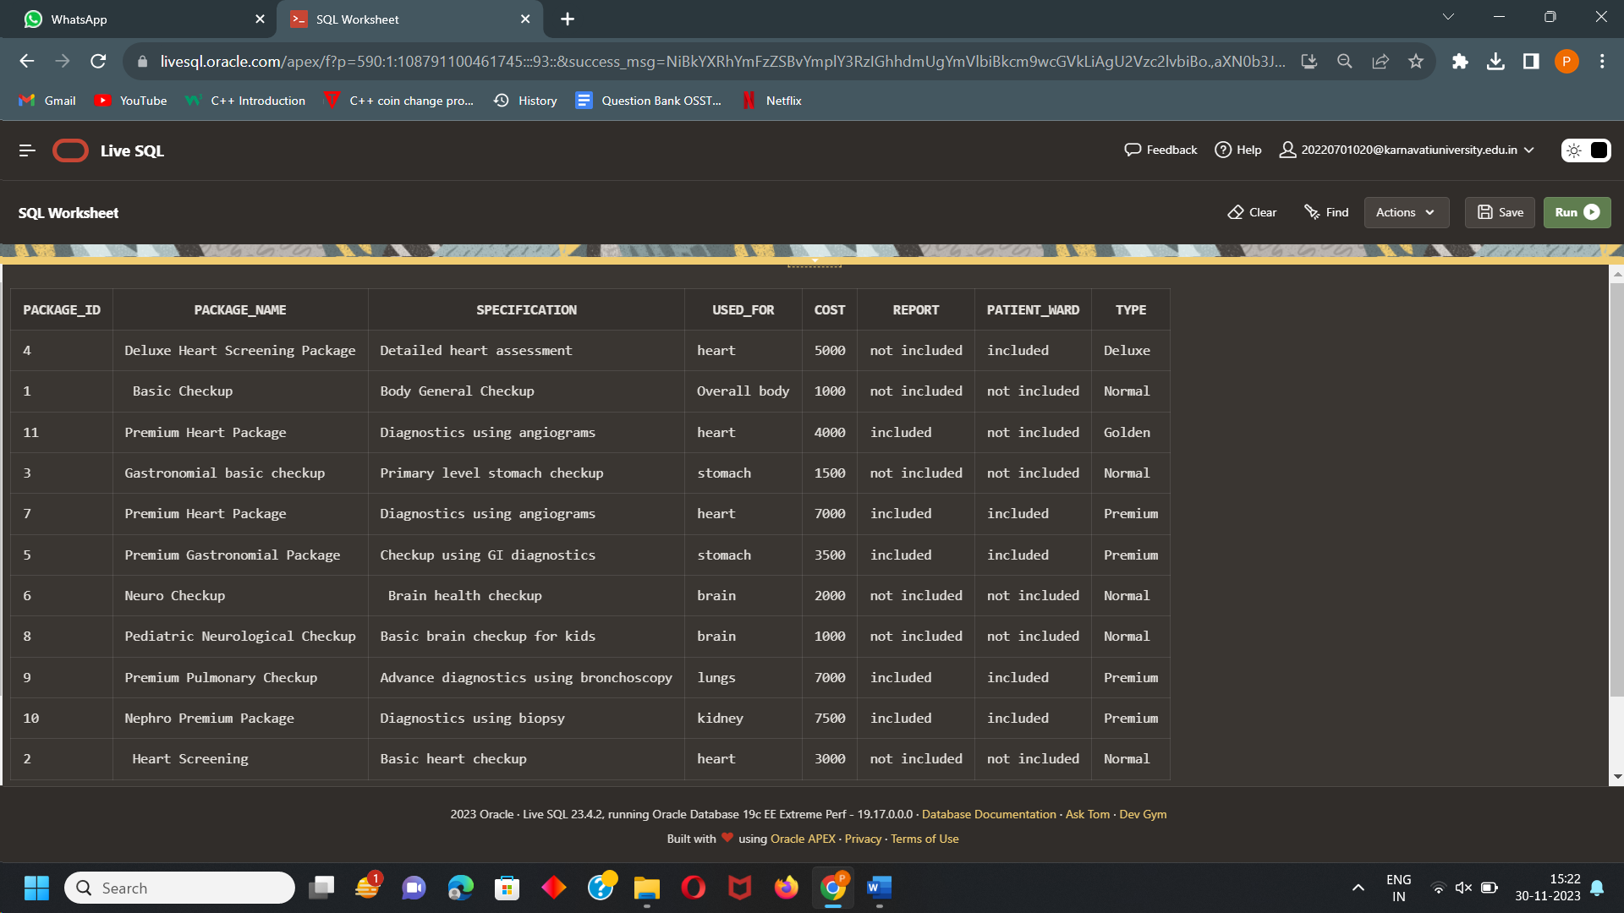

CREATION OF REPORTS TABLE

create table REPORTS

(

Report_Name varchar(70),

material_used varchar(70),

sample varchar(70),

detects varchar(70),

packages numeric,

time_duration_in_hours int not null

);

INSERT INTO REPORTS (Report_Name, material_used, sample, detects, packages,time_duration_in_hours)

VALUES('MRI','large magnet, radio waves, computer',' 3D image','Cancer and joint injury.','4000','48');

INSERT INTO REPORTS (Report_Name, material_used, sample, detects, packages,time_duration_in_hours)

VALUES('CT SCAN','x-ray machine, computer','XRAY IMAGES','bone tumors and lung problems.','2000','48');

INSERT INTO REPORTS(Report_Name, material_used, sample, detects, packages,time_duration_in_hours)

VALUES('EEG','neoprene cap, Control Box, electrodes','scalp of human body','changes in brain activity','1500','24');

INSERT INTO REPORTS(Report_Name, material_used, sample, detects, packages,time_duration_in_hours)

VALUES('CA','radiographic table, x-ray tubes, video monitor','lexible tube is inserted into an artery','blockage in heart and heart abnormalities','5000','72');

INSERT INTO REPORTS(Report_Name, material_used, sample, detects, packages,time_duration_in_hours)

VALUES('CBC','automated hematology analyzer','sample of blood ','infections and blood count','500','12');

Select * from REPORTS;

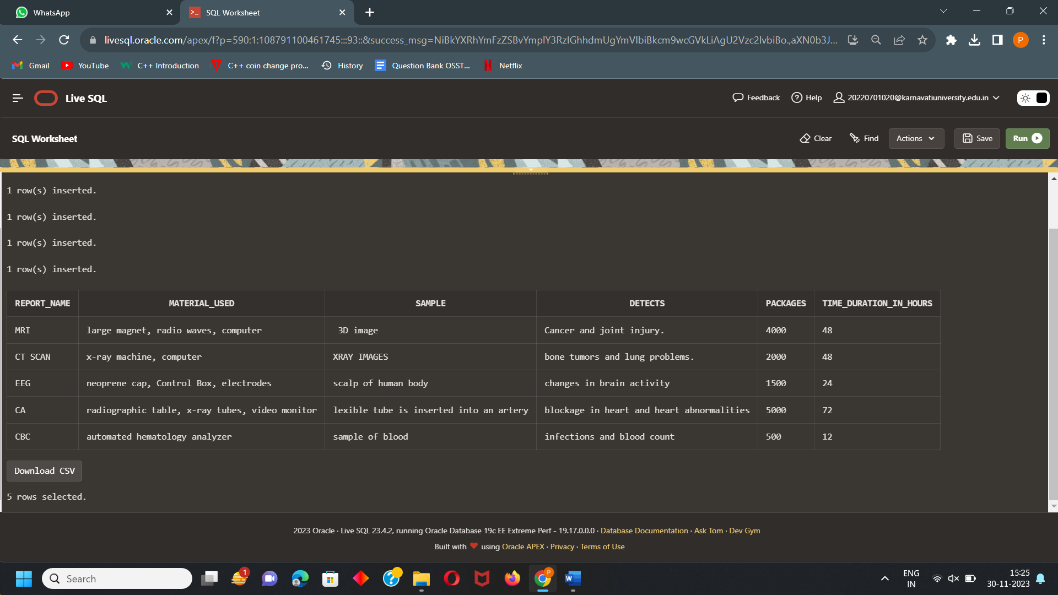

CREATION OF ILLNESS TABLE

create table illness

(

name varchar(70),

symptoms varchar(200),

medication varchar(70),

surgery varchar(70),

suggested_report varchar(70)

);

INSERT INTO illness(name, symptoms, medication, surgery, suggested_report)

VALUES('Cancer','Bladder Changes and bleeding','suggested by surgeon','if needed','MRI');

INSERT INTO illness(name, symptoms, medication, surgery, suggested_report)

VALUES('Bone tumors','swelling and difficulty in making movement','suggested by surgeon','if needed','CT SCAN');

INSERT INTO illness(name, symptoms, medication, surgery, suggested_report)

VALUES('brain disorders','Partial or complete loss of vision and Deafness','suggested by surgeon','not possible','EEG');

INSERT INTO illness(name, symptoms, medication, surgery, suggested_report)

VALUES('blockage in heart','crushing chest pain and shortness of breath','suggested by surgeon','necessary','CA');

INSERT INTO illness(name, symptoms, medication, surgery, suggested_report)

VALUES('mineral deficiencies','loss of taste and weakness ','suggested by surgeon','not necessary','CBC');

INSERT INTO illness(name, symptoms, medication, surgery, suggested_report)

VALUES('damaged ligaments','Severe pain and inability to continue activity','suggested by surgeon','not necessary','MRI');

INSERT INTO illness(name, symptoms, medication, surgery, suggested_report)

VALUES('problems of lungs','shortness of breath and coughing up mucus','suggested by surgeon','as per suggested','CT SCAN');

Select * from ILLNESS;

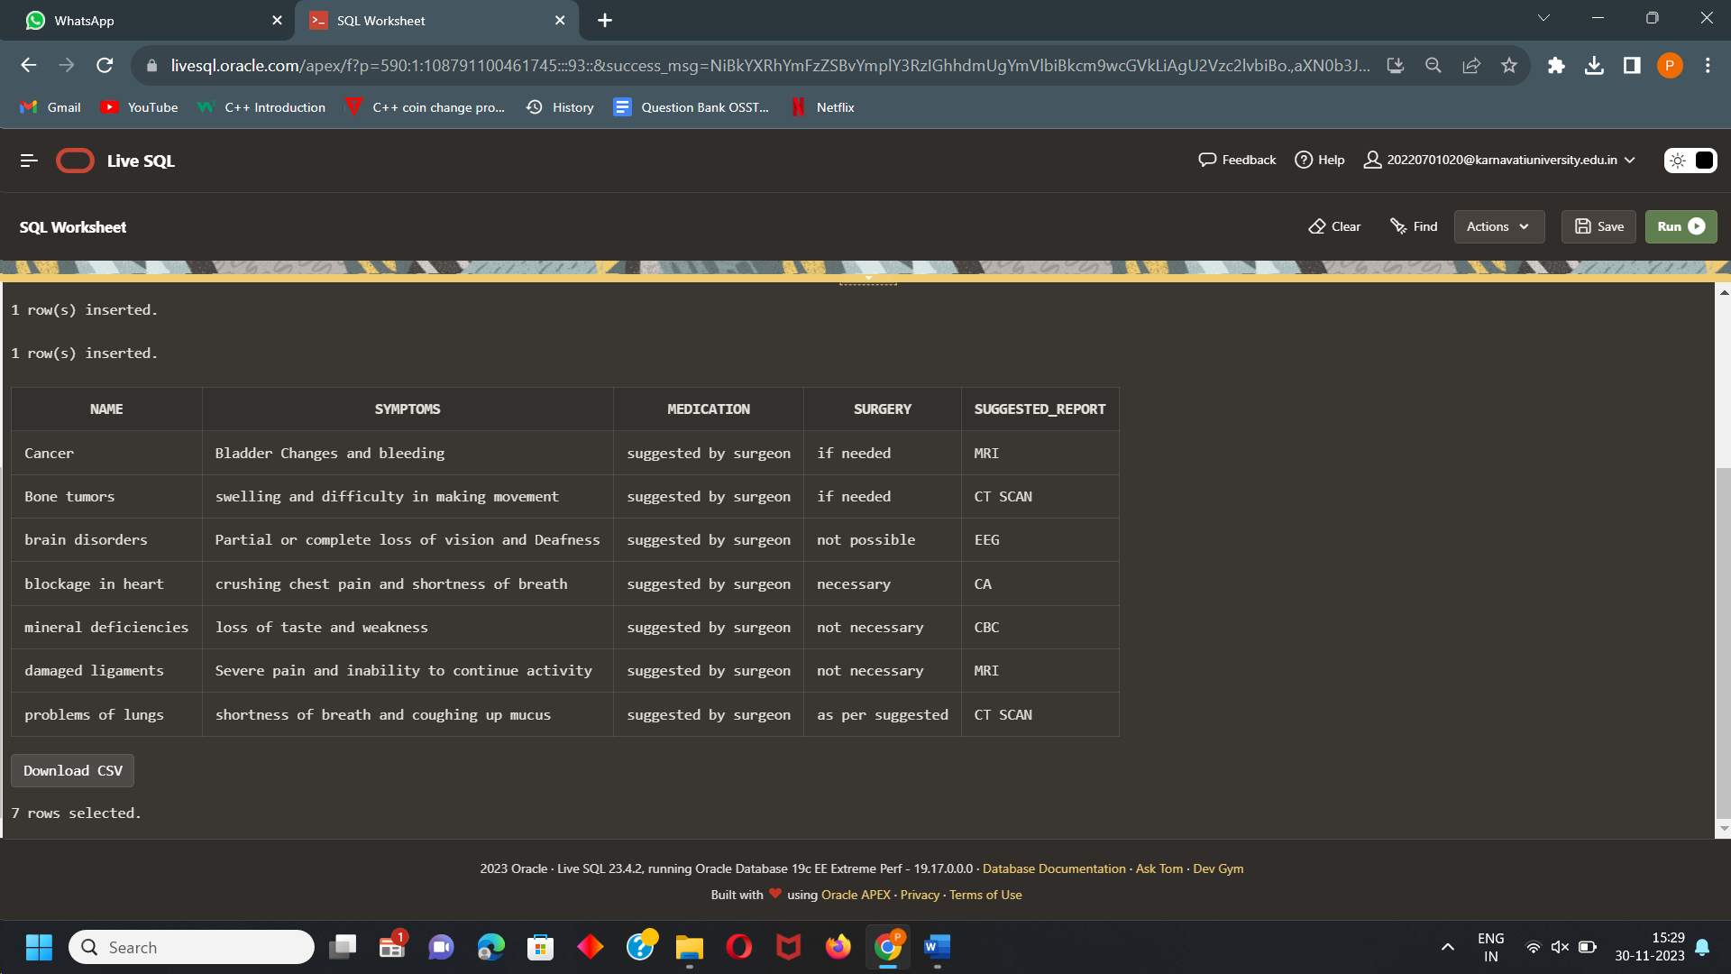

CREATION OF PATIENT TABLE

CREATE TABLE PATIENT

(

First_NAME VARCHAR2(70),

Last_NAME VARCHAR2(70),

phone_number varchar(70),

AGE INTEGER,

problem varchar(70),

GENDER CHAR(6),

Patient_ID NUMBER(30)

);

INSERT INTO PATIENT(First_NAME,Last_NAME,phone_number, AGE, problem,GENDER, Patient_ID)

VALUES('Aditya','Mehta','7658493290','30','pain in left leg bone','Male','101');

INSERT INTO PATIENT(First_NAME,Last_NAME,phone_number, AGE, problem,GENDER, Patient_ID)

VALUES('Aneri','Patel','7658013425','25','ligament injury','Female','102');

INSERT INTO PATIENT(First_NAME,Last_NAME,phone_number, AGE, problem,GENDER, Patient_ID)

VALUES('Anjali','Sharma','9876193290','50','pain in chest','Female','103');

INSERT INTO PATIENT(First_NAME,Last_NAME,phone_number, AGE, problem,GENDER, Patient_ID)

VALUES('Leela','Gujpta','8213493290','20','weakness','Female','104');

INSERT INTO PATIENT(First_NAME,Last_NAME,phone_number, AGE, problem,GENDER, Patient_ID)

VALUES('Jaya','Shah','9329023459','40','shortness in breathe','Female','105');

INSERT INTO PATIENT(First_NAME,Last_NAME,phone_number, AGE, problem,GENDER, Patient_ID)

VALUES('Krina','Patel','7234593290','45','Visual hallucinations','Female','106');

Select * from PATIENT;

